**Prototyping:**

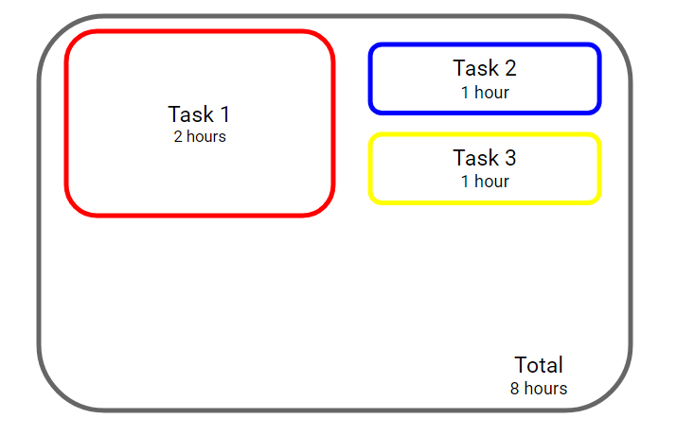

* User gives the total time they have to complete task and how long each task takes to complete
  + It makes users want to complete difficult tasks instead of doing
* Uses size of task to represent the importance / time to complete
  + We could have other versions users could choose between that emphasize these aspects in different ways
* Color could represent type of task

A different prototyping

* Tell users what task they should do next based off an AI algorithm

**Ideas:**

* Group Sharing:
  + Allow multiple people to access the todo list
  + People can be invited in way similar to google sharing
* Gamification:
  + Points are awarded for completing tasks, so you score points by doing things.
  + Points are valued by time, importance, and some randomness
  + Scoreboard of all people using the todo list
  + Incentivize users to do more work
* Notifications
  + Notify users when tasks need to be completed or have been finished

**To Do:**

* Create more prototypes
* Survey what other people like/would use
* Decide on more concrete ideas